AI-Driven Multi-Clinic Healthcare Appointment and Resource Optimization Platform

PHASE 1 REPORT

Submitted by

Sheryl Katrina M -230701310
Shalini R K – 230701304
Senthamizh Selvi V – 230701301
Sangamithran A - 230701283

In partial fulfillment for the award of the degree of

BACHELOR OF ENGINEERING IN
COMPUTER SCIENCE AND ENGINEERING



RAJALAKSHMI ENGINEERING COLLEGE ANNA UNIVERSITY, CHENNAI
OCTOBER – 2026

ANNA UNIVERSITY, CHENNAI BONAFIDE CERTIFICATE

Certified that this Report titled "AI-Driven Multi-Clinic Healthcare Appointment and Resource Optimization Platform " is the bonafide work of Sheryl Katrina M (230701310), Shalini R K (230701304), Senthamizh Selvi V (230701301), Sangamithran A (230701283) who carried out the work under my supervision. Certified further that to the best of my knowledge the work reported herein does not form part of any other thesis or dissertation on the basis of which a degree or award was conferred on an earlier occasion on this or any other candidates.
This project addresses the following Sustainable Development Goal:
Goal- No :3 Good Health and Well-being.

SIGNATURE  Dr. J. Manoranjini.,  Professor and Head,  Department of Computer Science and Engineering,  Rajalakshmi Engineering College,  Chennai-602 105. | SIGNATURE  Mr. N. Karthikeyan, M.E.,  Assistant Professor,  Department of Computer Science and Engineering,  Rajalakshmi Engineering College,  Chennai-602 105.

Submitted to Project Viva-Voce Examination held on

Internal Examiner External Examiner

ABSTRACT

Healthcare clinics are essential for offering affordable and effective medical services. However, they do encounter challenges like long waiting times, ineffective appointment scheduling, uneven workload of doctors, manual queue management, and fragmented patient and pharmacy records. - Reduced patient satisfaction, increased administrative burden and impact on the efficiency of the overall health delivery. The proposed project, Med-link proposes an AI-powered clinic management framework which incorporates intelligent patient triage, adaptive appointment scheduling, digital consultation management and pharmacy inventory management. The system uses AI-based symptom analysis to assist in deciding patient priority and sort the queue according to urgency of condition. An adaptive scheduling module takes into account patient priority, doctor availability and expected consultation duration to optimize appointment allocation and balance doctor workload. The web-based platform allows patients to get information on appointments, queue status, and automated notifications. Healthcare professionals are able to efficiently manage digital patient records and consultation details. The pharmacy module monitors medicine availability and helps to identify possible stock shortages. Unlike conventional clinic management systems that rely on manual scheduling and record keeping, MedLink uses intelligent decision-making, automated workflow management and centralized healthcare data management. The framework helps to reduce the waiting time of patients, improve the use of resources, improve the distribution of work and improve the operational efficiency of the clinic. MedLink’s combination of artificial intelligence and digital healthcare management offers a new, scalable approach to the real-world problems of today’s clinical settings.

ACKNOWLEDGEMENT

Initially we thank the Almighty for being with us through every walk of our life and showering his blessings through the endeavor to put forth this report. Our sincere thanks to our Chairman Mr. S.MEGANATHAN, B.E, F.I.E., our Vice Chairman Mr. ABHAY SHANKAR MEGANATHAN, B.E., M.S., and our respected Chairperson Dr. (Mrs.) THANGAM MEGANATHAN, Ph.D., for providing us with the requisite infrastructure and sincere endeavoring in educating us in their premier institution.
Our sincere thanks to Dr. S.N. MURUGESAN, M.E., Ph.D., our beloved Principal for his kind support and facilities provided to complete our work in time. We express our sincere thanks to Dr. J. Manoranjini., Professor and Head of the Department of Computer Science and Engineering for his guidance and encouragement throughout the project work. We convey our sincere and deepest gratitude to our internal guide, Mr. N. Karthikeyan., M.E., Assistant Professor, Department of Computer Science and Engineering for his valuable guidance throughout the course of the project. We thank our Project Coordinator, Dr.S.MADHUSUDHANAN., Associate Professor, Department of Computer Science and Engineering for his useful tips during our review to build our project.

SHERYL KATRINA M : 230701310
SHALINI R K : 230701304
SENTHAMIZH SELVI V : 230701301
SANGAMITHRAN A : 230701283

TABLE OF CONTENT

CHAPTER NO. | TITLE | PAGE NO..
 | ABSTRACT  LIST OF FIGURES  LIST OF ABBREVIATIONS | iii  vii  viii
1. | INTRODUCTION  - GENERAL  - OBJECTIVE  - EXISTING SYSTEM  - PROPOSED SYSTEM | 01
2. | LITERATURE SURVEY  - LITERATURE REVIEW  - COMPARISON AND DISCUSSION  - CONCLUSION | 05
3. | SYSTEM DESIGN  - SYSTEM ARCHITECTURE  - SYSTEM REQUIREMENTS  - SOFTWARE REQUIREMENTS  - HARDWARE REQUIREMENTS  - SYSTEM DESIGN  - ACTIVITY DIAGRAM  - DATA FLOW DIAGRAM | 09
4. | PROJECT DESCRIPTION  - METHODOLOGIES  - MODULES  - USER AUTHENTICATION AND ROLE MANAGEMENT MODULE CORE PACKAGE | 17

    - CLINIC DISCOVERY AND RECOMMENDATION MODULE REINFORCEMENT PACKAGE
    - APPOINTMENT AND DOCTOR AVAILABILITY MODULE
    - LIVE OPD QUEUE MANAGEMENT MODULE
    - AI-BASED SYMPTOM ANALYSIS AND CLINICAL TRIAGE MODULE
    - PHARMACY INVENTORY AND DEMAND FORECASTING MODULE
4.3 SUMMARY OF AI MODEL EVALUATION

5. | IMPLEMENTATION AND RESULT DISCUSSION  - IMPLEMENTATION RESULTS  - IMPLEMENTATION OF DATA PRE-PROCESSING  - IMPLEMENTATION OF DATA TOKENIZATION  - IMPLEMENTATION OF FEATURE VECTORISATION AND FEATURE ENGINEERING.  - EXPECTED RESULT  5.2.1 QUANTITATIVE PERFORMANCE BENCHMARKS  5.2.2 DETAILED EVALUATION ANALYSIS  - DISCUSSION | 31
6. | CONCLUSION AND FUTURE WORK  - CONCLUSION  - FUTURE WORK  REFERENCES | 38

LIST OF FIGURES

Figure No. | Title | Page No.
Figure 3.1 | End-to-End System Architecture of the MedLink Healthcare Optimization Platform | 17
Figure 3.2 | End-to-End System Workflow | 22
Figure 3.3 | End-to-End Data Flow Diagram of the MedLink Platform. | 23
Figure 4.1 | MedLink Clinic Dashboard for Appointment, Queue and Doctor Management | 34
Figure 4.2 | MedLink Patient Healthcare Discovery and AI-Based Department Recommendation Interface | 35
Figure 4.3 | MedLink Pharmacy Interface for Adding Medicine Stock and Batch Details | 36
Figure 4.4 | MedLink Digital Pharmacy and FEFO-Based Inventory Management Dashboard. | 37
Figure 5.1 | Evaluation metrics and status. | 39
Figure 5.2 | Feature Vectorization pipeline for symptom-routing and demand forecasting module. | 42
Figure 5.3 | Quantitative performance Benchmark. | 43
Figure 5.4 | Comparison of Model Performance Across Architectures. | 44

LIST OF ABBREVATION

Abbreviation | Description
AI | Artificial Intelligence
API | Application Programming Interface
Bi-LSTM | Bidirectional Long Short-Term Memory
DPI | Dots Per Inch (Image Resolution)
EHR | Electronic Health Record
ETA | Estimated Time of Arrival
FCFS | First-Come, First-Served (Baseline Model)
FEFO | First-Expired, First-Out
HTML | HyperText Markup Language
MAE | Mean Absolute Error
NLP | Natural Language Processing
OPD | Outpatient Department
PNG | Portable Network Graphics
Q-Learning | Model-Free Reinforcement Learning Algorithm
REST | Representational State Transfer
RMSE | Root Mean Square Error
UI / UX | User Interface / User Experience
CDN | Content Delivery Network

CHAPTER 1 INTRODUCTION

  - GENERAL

Accessible and timely medical services to patients are provided by healthcare clinics in an essential role. Nevertheless, a significant number of clinics continue to use traditional and manual methods to oversee pharmacy operations, consultations, patient queues, and appointments. With the increase in number of patients, these methods can lead to inefficient scheduling, long waiting times, uneven distribution of patients to doctors and difficulties in maintaining accurate patient records. Healthcare personnel may also find it hard to identify and treat patients based on the urgency of their conditions without intelligent prioritization.

The proposed AI-Powered Clinic Management System is an effort to solve these problems by integrating Artificial Intelligence with the necessary clinic management operations. The platform offers intelligent patient triage, adaptive appointment scheduling, automated queue management, digital consultation management and pharmacy inventory management in a single platform. The AI based triage module assists in determining the priority of the patients based on their symptoms and other relevant information. The scheduling module considers factors like priority of the patient, availability of the doctor, expected time for consultation, etc. to arrange the appointments effectively. In addition, automated notifications and reminders can help reduce appointment no-shows and improve communication between patients and the clinic.

The system will combine intelligent decision making with centralized digital management to improve the overall efficiency and reliability of clinic operations. Healthcare providers are able to manage patient information, consultations, appointments and medicine availability from one platform and patients can have a better organized appointment and queue experience. The system is designed to reduce administrative workload, reduce unnecessary waiting time, improve doctor workload distribution and support effective utilization of clinic resources . Hence, the proposed solution offers a scalable and intelligent way to modernize traditional clinic management and enhance the quality of healthcare service delivery.

OBJECTIVE

The main aim of the AI-Powered Clinic Management System is to develop and deploy an intelligent healthcare management system which makes use of Artificial Intelligence to solve the problems which are presently affecting the working of traditional clinics.

- Intelligent Patient Triage: To build an AI-powered triage module that will assess patient symptoms and pertinent information to assign patient priority and assist healthcare staff in efficiently managing critical situations.
- Adaptive Appointment Scheduling: To create an intelligent scheduling mechanism to optimize appointment allocation and improve distribution of doctor workload by considering patient priority, doctor availability and expected consultation time.
- Automatic Queue Management: Develop a digital queue management system which prioritizes and organizes patient flow based on appointment status and priority, reducing unnecessary wait times and improving the patient experience.
- Digital Management of Consultations: To create a central digital platform that enables healthcare professionals to efficiently access and manage patient records, medical histories, appointment details and consultation information.
- Pharmaceutical Inventory Management: This will help design an inventory management module to facilitate pharmacy work and timely replenishment by monitoring the availability of the medicine, tracking the stock levels and identifying the potential shortage.
- Automated Notifications and Reminders: Implement an automated notification system for appointment confirmations, upcoming appointments, and relevant updates to improve patient communication and minimize missed appointments.
The achievement of these goals will revolutionize the traditional clinic management into a more patient-centered, efficient, and intelligent health care service that will enhance the utilization of resources, reduce the administrative load, cut down the waiting time, and improve the general quality of the clinic operations.

EXISTING SYSTEM

At present, the clinic management system mainly uses manual and simple electronic devices to conduct patient registration, appointment scheduling, queue management, consultation records, and pharmacy activities. These systems are able to support the routine administrative tasks, but they are unable to make intelligent decisions to effectively prioritize patients according to their symptoms and urgency. Appointment schedules are often created based on fixed time slots and doctor availability that can lead to overlapping appointments, skewed doctor workloads, and increased patient waiting times especially during peak hours. In addition, existing systems do not adequately support dynamic management of patient queues as clinical priorities change.
Many clinics still manage and monitor patients manually as a core part of their operations with the help of receptionists and healthcare staff. These techniques can be time-consuming, subjective and hard to scale as patient volume increases. Moreover, storing patient records and consultation information in separate systems or physical documents can complicate information retrieval and coordination. In pharmacies, the inventory is often monitored manually, which leads to inefficient inventory management and slow identification of low-stock medicines. Some clinics have implemented electronic health records and online appointment systems, but these solutions tend to be more about digitizing existing processes than enabling intelligent automation.
A further major constraint of today’s systems is the lack of AI-powered adaptability and embedded decision support. Traditional platforms generally do not use patient, appointment or operational data to improve resource allocation and scheduling. They also have limited automation for patient communication and appointment reminders which could lead to missed appointments. This results in lower patient satisfaction, underutilized clinic and doctors, longer waiting time, and increased administrative workload. These limitations highlight the need for intelligent and integrated system of clinic management which is feasible to real-time healthcare requirements.

1.4 PROPOSED SYSTEM

This AI-Powered Clinic Management System is developed to overcome the drawbacks of traditional clinic management systems and provides an intelligent and integrated healthcare framework. The proposed system integrates AI-based Patient Triage, Adaptive Appointment Scheduling, Automated Queue Management, Digital Consultation Management and Pharmacy Inventory Management on one platform. The Patient Triage Module evaluates patient symptoms and pertinent information to identify the priority of cases, assisting healthcare professionals in managing patients effectively and providing timely urgent care.
The Adaptive Appointment Scheduling Module generates an efficient appointment schedule based on patient priority, doctor availability and estimated consultation duration. The system also provides automated queue management to ease patient flow and reduce the unnecessary waiting time. Appointment notifications and reminders are implemented to enable communication with patients and to reduce missed appointments. These features facilitate a more efficient distribution of workload among physicians during periods of high patient volume.
The proposed system offers a single digital platform to manage patient records, medical history, appointments and consultation details. Healthcare providers are able to access and update patient information easily, which leads to better availability of information and less reliance on manual records. The Pharmacy Inventory Module helps to manage inventory effectively and ensure timely replenishment by monitoring levels of medicine stock and identifying possible shortages.
The system is modular in design, so each of the components can be operated in isolation, but still integrated into the overall platform. The proposed system aims to reduce the administrative workload, minimize patient waiting time, optimize resource allocation, improve doctor's workload distribution and increase patient satisfaction by integrating automated clinic operations with Artificial Intelligence. All in all, the system provides a patient-eccentric, scalable and intelligent way of managing a modern clinic.

CHAPTER 2 LITERATURE SURVEY

The rapid development of digital healthcare technologies, machine learning and Artificial Intelligence has led to the creation of intelligent healthcare management systems that are designed to improve operational efficiency and patient care. Existing clinic management solutions are generally limited to appointment booking, patient registration, record maintenance and not well addressed in terms of adaptive scheduling, intelligent patient prioritization, patient flow and utilization of resources. Against this background, research papers on AI-based triage, scheduling of healthcare appointments, prediction of patient no-shows and decision support in clinical care are highly relevant. This chapter reviews the key works in these areas, with a focus on their methodologies, benefits and drawbacks, and their role in shaping the proposed AI-Powered Clinic Management System.

2.1. LITERATURE REVIEW

The Role of Artificial Intelligence in Enhancing Triage Decisions in Healthcare Settings,
A Systematic Review” examines the use of machine learning and AI methods to improve patient triage. The review of studies from 2020 to 2025 found that AI-based systems can improve the consistency, efficiency and accuracy of triage decisions and thus help health professionals. The techniques reviewed were deep learning, machine learning, hybrid approaches and natural language processing. However, the study also identified challenges related to ethical issues, usability, trust and tailoring to different healthcare settings. The proposed system demonstrates the potential of AI-based triage to support healthcare staff in prioritization of patients and the importance of explainable and responsible decision support. The paper “Appointment Scheduling Problem in Complexity Systems of the Healthcare Services: A Comprehensive Review” offers a wide overview of the methods for scheduling healthcare appointments. The study reviewed more than 150 research papers and examined a number of variables including patient flow, patient preferences, random arrivals and service times. We examined the reduction of patient waiting time by several methods, such as mathematical optimization, simulation models, Markov models, and artificial intelligence. improving healthcare resource utilization. The study indicates that intelligent scheduling can improve patient satisfaction while reducing idle time and operational inefficiencies.
The Role of Artificial Intelligence in Enhancing Triage Decisions in Healthcare Settings: A Systematic Review examines the use of machine learning and AI methods to improve patient triage. The review of studies from 2020 to 2025 found that AI-based systems can improve the consistency, efficiency and accuracy of triage decisions and thus help health professionals. The techniques reviewed were deep learning, machine learning, hybrid approaches and natural language processing. However, the study also identified challenges related to ethical issues, usability, trust and tailoring to different healthcare settings. The proposed system demonstrates the potential of AI-based triage to support healthcare staff in prioritization of patients and the importance of explainable and responsible decision support.
The paper “Appointment Scheduling Problem in Complexity Systems of the Healthcare Services: A Comprehensive Review” offers a wide overview of the methods for scheduling healthcare appointments. The study reviewed more than 150 research papers and examined a number of variables including patient flow, patient preferences, random arrivals and service times. We examined the reduction of patient waiting time by several methods, such as mathematical optimization, simulation models, Markov models, and artificial intelligence. The study “Artificial Intelligence Applications Using Patient-Generated Health Data for Pre-Care Processes in Elective Healthcare: A Systematic Review” investigates how AI can use patient-generated health information to support pre-care processes such as triage, symptom assessment, and medical history collection. The research demonstrates the potential of AI to improve the preparation of patient information before clinical interaction. This approach is relevant to the proposed system because collecting and analyzing patient symptoms before consultation can support more organized patient prioritization and improve the efficiency of clinic workflows.

2.2 COMPARISON AND DISCUSSION

The reviewed literature demonstrates that AI and machine learning can significantly contribute to improving healthcare management, particularly in patient triage, appointment scheduling, and prediction of missed appointments. Traditional appointment systems mainly depend on fixed schedules and manual intervention, whereas intelligent systems can analyze historical and real-time information to support better decision-making. Studies on AI-based triage indicate that machine learning and deep learning can assist in prioritizing patients and improving the consistency of healthcare decisions. However, the reviewed research also emphasizes the importance of trust, interpretability, ethical considerations, and human supervision when applying AI in healthcare. Therefore, the proposed system focuses on using

AI as a decision-support mechanism rather than replacing healthcare professionals. In appointment management, existing studies demonstrate the effectiveness of predictive models and optimization techniques for reducing waiting time, improving resource utilization, and managing patient no-shows. However, many approaches focus on individual problems such as scheduling or no-show prediction rather than integrating multiple clinic operations into a single platform. The proposed AI-Powered Clinic Management System addresses this gap by integrating patient triage, adaptive appointment scheduling, automated queue management, digital consultation management, and pharmacy inventory management within a unified framework. This integration enables information generated by one module to support decision-making in other modules. For example, patient priority can influence appointment scheduling, while appointment information can support queue management and automated reminders. Overall, the comparison indicates that existing research provides strong individual solutions, but there remains an opportunity to combine these approaches into a holistic, intelligent, and scalable clinic management framework. The proposed system aims to bridge this gap by integrating AI-driven decision support with essential clinic management operations.

2.3. CONCLUSION

In summary, the reviewed studies demonstrate the growing role of Artificial Intelligence and machine learning in modern healthcare management. AI-based triage can support patient prioritization, predictive scheduling can improve resource utilization, and machine learning-based no-show prediction can help reduce missed appointments. However, existing approaches often focus on specific healthcare processes rather than providing an integrated solution for overall clinic operations.

The proposed AI-Powered Clinic Management System aims to bridge this gap by combining intelligent patient triage, adaptive appointment scheduling, automated queue management, digital consultation management, and pharmacy inventory management into a unified platform. By integrating these capabilities, the system seeks to provide a more efficient, adaptive, patient-centric, and data-driven approach to clinic management, while supporting healthcare professionals in making better operational decisions.

CHAPTER 3 SYSTEM DESIGN
System design is the process of translating the requirements of the AI-Powered Clinic Management System into a structured framework. It defines the system architecture, modules, and data flow. The system integrates AI-based Patient Triage, Adaptive Appointment Scheduling, and Automated Queue Management. It also includes Digital Consultation, Pharmacy Inventory, and Automated Notification modules. The design ensures efficient data management, intelligent decision-making, reliability, scalability, and improved clinic efficiency..

SYSTEM ARCHITECTURE

The AI-Powered Clinic Management System is designed as a modular and integrated healthcare framework that connects patients, doctors, and clinic assistants through dedicated user applications and a centralized backend. The frontend layer consists of a Patient Mobile App, Doctor Mobile App, and Clinic Assistant Portal, each providing role-specific functionalities. Patients can register, authenticate, book appointments, track queues, view health records, and receive notifications. Doctors can manage appointments, availability, consultations, clinical notes, and patient history, while clinic assistants can manage clinic operations, appointments, patient check-ins, queues, inventory, and reports. All applications communicate with the backend through secure HTTPS REST APIs and Socket.IO for real-time updates.

The Backend and Core Services form the central processing layer of the system and are responsible for managing the major clinic operations. This layer includes Authentication and Authorization, User Management, Appointment Service, OPD Queue Engine, Recommendation Engine, Notification Service, File Storage Service, and Audit Logging. The Appointment Service supports booking, rescheduling, and cancellation, while the OPD Queue Engine manages patient flow and provides real-time queue updates. The Recommendation Engine supports procedure and department recommendations, and the Notification Service manages in-app, email, and SMS notifications. These services are connected through the MediLink Backend API, which contains the RESTful API layer, business logic layer, service integration layer, Socket.IO event handler, and data access layer.

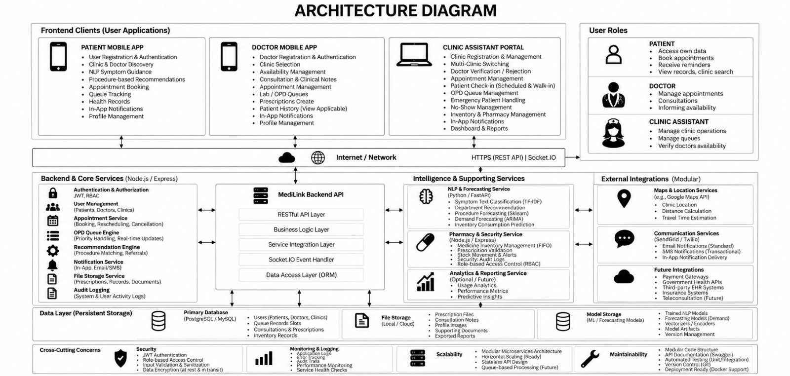
Figure 3.1: End-to-End System Architecture of the MedLink Healthcare Optimization Platform
The Intelligence and Supporting Services provide AI-driven capabilities to improve clinic decision-making and operational efficiency. The NLP and Forecasting Service uses Python and FastAPI to perform symptom classification, department recommendation, procedure forecasting, demand forecasting, and inventory consumption prediction. The system also includes a Pharmacy and Security Service for medicine inventory management, prescription validation, stock movement and alerts, security audit logs, and role-based access control. An optional Analytics and Reporting Service supports usage analytics, performance metrics, and predictive insights. The system is further connected to external integrations such as Maps and Location Services for clinic location, distance calculation, and travel-time estimation, along with communication services for email, SMS, and in-app notifications. The Data Layer provides persistent storage for the information generated and processed by the system. The primary database stores users, doctors, patients, clinics, queue records, consultations, prescriptions, and inventory records. File storage maintains prescription files, consultation notes, profile images, supporting documents, and exported reports, while model storage maintains trained NLP and forecasting models, vectorizers, model artifacts, and version information. Cross-cutting concerns such as security, monitoring, logging, scalability, and maintainability are applied throughout the architecture. JWT authentication, role-based access control, input validation, data encryption, application logs, performance .

3.2 SYSTEM REQUIREMENTS

The AI-Powered Clinic Management System is designed to provide intelligent patient triage, adaptive appointment scheduling, queue management, digital consultation, pharmacy inventory management, and automated notifications. To ensure proper development, deployment, and operation, the system requirements can be classified into functional and non-functional requirements. Hardware and Software Requirements To ensure smooth development, deployment, and operation of the AI-Powered Clinic Management System, the following hardware and software specifications are recommended.

3.2.1 Hardware Requirements:

      - Server/Processing Unit

        - Multi-core processor (Intel i5/i7 or equivalent) for handling backend services and AI-based processing. Minimum 16 GB RAM for efficient execution of machine learning algorithms.
        - Minimum 16 GB RAM for efficient execution of AI models, databases, and multiple services.
        - SSD storage (500 GB or more) for storing patient records, consultation data, pharmacy information, and AI models.

User Devices

        - Smartphones or tablets for patients and doctors to access their respective mobile applications.
        - Desktop/laptop computers for clinic assistants to manage appointments, queues, patient records, inventory, and reports.

Networking

        - Stable internet connectivity for communication between frontend applications, backend services, and external services.
        - Secure network connectivity to support HTTPS REST APIs and Socket.IO for real-time communication and queue updates

Supporting Devices

        - A reliable display and input system for clinic staff to monitor appointments, patient queues, consultations, and pharmacy inventory.
        - Adequate local or cloud-based storage for maintaining documents, prescriptions, consultation notes, and exported reports.

The hardware setup ensures that the AI-Powered Clinic Management System can efficiently handle patient information, appointments, real-time queue updates, AI processing, and pharmacy operations. By providing adequate processing power, memory, storage, and network connectivity, the system can support multiple users simultaneously while maintaining reliable performance. This setup also provides flexibility for future expansion, such as increasing the number of users, clinics, services, and AI-based features.

3.2.2 Software Requirements:

1. Operating System

Windows 10/11 or Linux (Ubuntu 20.04 or later) for development, testing, and server environments.

2. Development Tools and Languages

Python 3.x for implementing AI-based patient triage, prediction, and data processing modules.

JavaScript/TypeScript for developing frontend applications and interactive web interfaces.

Node.js with Express.js for implementing backend services and RESTful APIs.

React.js for developing responsive web applications and clinic management portals.

3. Libraries and Frameworks

Machine Learning: Scikit-learn and related Python libraries for symptom classification, recommendations, and predictive analysis.

Data Processing: Pandas and NumPy for data preprocessing, analysis, and manipulation.

Backend Communication: Socket.IO for real-time queue updates and notifications.

4. Database Management System

PostgreSQL/MySQL for storing patient details, doctor information, appointments, consultations, prescriptions, and inventory records.

File/Cloud Storage for maintaining consultation documents, prescriptions, reports, and other supporting files.

5. Additional Tools

Version Control: Git/GitHub for source-code management, collaboration, and version tracking.

API Documentation: Swagger/OpenAPI for documenting and testing RESTful backend services.

External APIs: Maps and communication APIs for location services, distance estimation, email, SMS, and notification delivery.

The recommended software stack ensures that the AI-Powered Clinic Management System can efficiently support intelligent healthcare operations, real-time communication, and secure data management. By combining modern development frameworks, machine learning libraries, database technologies, and external services, the system can handle patient management, appointment scheduling, queue monitoring, consultation records, and pharmacy operations effectively. Furthermore, this configuration provides flexibility for integrating additional AI models, services, and features in the future, ensuring that the system remains scalable, maintainable, and adaptable to evolving healthcare requirements.

SYSTEM DESIGN

The AI-Powered Clinic Management System design model describes how patient and clinic data moves from raw inputs to informed healthcare decisions through a series of structured processing stages. The system gathers patient symptoms, appointment details, doctor availability, consultation records, and pharmacy data through the respective user applications. Once this data has been validated and preprocessed, it is passed to the AI-based Patient Triage Module and the Adaptive Appointment Scheduling Module, which work together to establish patient priority and allocate appointments as efficiently as possible. The Automated Queue Management Module then takes their outputs and organizes the patient flow, while the Digital Consultation and Pharmacy modules handle clinical records and medicine inventory. The Notification and Analytics services draw on this processed information to deliver real-time updates, timely reminders, and useful operational insights. Overall, this design supports a smooth flow of data, intelligent decision-making, real-time responsiveness, and dependable clinic management.

Activity Diagram:

The activity diagram shows the step-by-step workflow of the AI-Powered Clinic Management System. It starts with patient registration and the collection of details such as symptoms, appointment information, and medical history, which are then validated and preprocessed. This processed information is passed to the AI-based Patient Triage Module and the Adaptive Appointment Scheduling Module, which decide the patient's priority and assign suitable appointment slots. The Automated Queue Management Module then arranges the patient flow according to priority and appointment status, while the Digital Consultation Module takes care of consultation records and prescriptions. The Pharmacy Inventory Module keeps medicine stock up to date and raises alerts whenever they are needed, and the Notification Module sends appointment reminders and real-time updates to users. Altogether, this workflow supports efficient patient management, shorter waiting times, and better coordination across clinic operations.

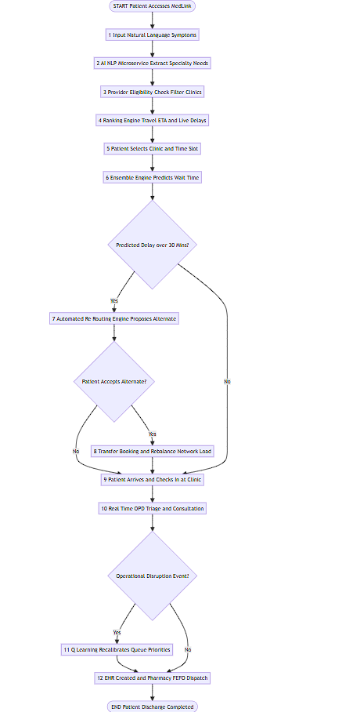

Figure 3.2: End-to-End System Workflow

Data Flow Diagram
The data flow diagram shows how patient and clinic information is turned into meaningful healthcare outputs. Data coming from patients, doctors, and clinic assistants is first validated and processed by the backend. This processed data is then analyzed by the Patient Triage and Appointment Scheduling modules, and their results feed into the Queue Management, Digital Consultation, and Pharmacy Inventory modules. Finally, the information is stored and put to use for notifications, alerts, and analytics.

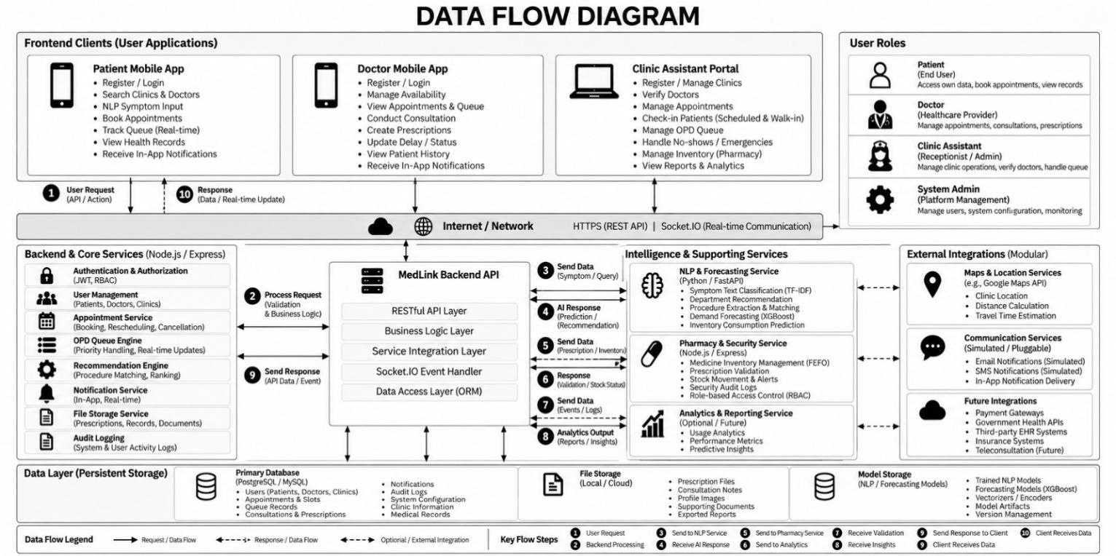

Figure 3.3: End-to-End Data Flow Diagram of the MedLink Platform.

The AI-Powered Clinic Management System follows an integrated AI-based methodology that brings together Patient Triage, Adaptive Appointment Scheduling, and Predictive Analytics to make clinic operations run more smoothly. The Patient Triage module studies patient symptoms and related information to judge how urgent each case is and to suggest the right department. The Appointment Scheduling module takes into account patient priority, doctor availability, and expected consultation duration when assigning suitable slots. Working alongside the Queue Management system, these intelligent modules help organize patient flow and cut down unnecessary waiting time.
Before any processing begins, the patient and clinic data is cleaned, validated, normalized, and, where needed, passed through feature extraction. This gives the AI modules consistent and dependable input to work with. The system applies predictive techniques to tasks such as procedure forecasting, demand forecasting, and inventory consumption prediction. The results are then connected to the backend services to support appointment management, queue organization, consultation handling, and pharmacy operations. Automated notifications and reminders are also generated from appointment and queue information, which improves communication with patients and helps reduce missed appointments.
The methodology is also built with scalability, security, and modularity in mind, so individual modules can be updated or improved without disturbing the rest of the system. Real-time communication through APIs and event-based services keeps queue updates, notifications, and operational monitoring timely. Centralized records of patients, appointments, consultations, prescriptions, and inventory make it easier to retrieve and analyze information when needed. Taken together, these methodologies offer an intelligent, reliable, and adaptable approach to modern clinic management, helping to lower administrative workload, make better use of resources, and improve the overall patient experience.

CHAPTER 4

PROJECT DESCRIPTION

  - METHODOLOGIES

MODULES
The MedLink Healthcare AI Platform is built as an integrated digital healthcare ecosystem that brings patients, doctors, clinic staff, pharmacy operations, and administrators together on a single platform. It combines web and mobile interfaces with a distributed backend, real-time communication services, artificial intelligence components, and persistent healthcare data management.
Its modular architecture keeps the major functional responsibilities separate, while still letting the modules communicate through REST APIs, WebSocket-based real-time events, and shared database services. This approach makes the system easier to maintain, scale, and secure, and it allows each healthcare function to be developed independently.
The major modules of the MedLink system are:
- User Authentication and Role Management Module
- Clinic Discovery and Recommendation Module
- Appointment and Doctor Availability Module
- Live OPD Queue Management Module
- AI-Based Symptom Analysis and Clinical Triage Module
- Pharmacy Inventory and Demand Forecasting Module
- Patient Health Records and E-Prescription Module
- Notification and Communication Module
- Administrative Dashboard and Analytics Module

4.2.1 USER AUTHENTICATION AND ROLE MANAGEMENT MODULE
The User Authentication and Role Management Module provides the security foundation of the MedLink platform. Since the system handles healthcare-related information, access to application features and patient information must be controlled according to the authenticated user's role.
The system supports several categories of users, including patients, doctors, clinic staff, and administrators. Authentication is implemented using JSON Web Tokens (JWT), so the backend can verify every authenticated request before granting access to protected resources.The module handles user authentication, authorization, identity resolution, and role-based access control. Passwords are protected using secure hashing mechanisms, and each authenticated request carries the authorization information needed to identify the user making it.
Role-based authorization makes sure users can only perform the operations that belong to their responsibilities. For example, patients can manage their own appointments and health records, doctors can access the relevant consultation and patient information, clinic staff can manage queues and appointments, and administrators can reach the management and analytics functions.
The module also supports verification workflows and related communication, such as OTP-based verification.
Major functionalities
· User registration and authentication
· JWT-based session authorization
· Role-based access control
· Password hashing
· OTP/verification workflows
· Protected API endpoints
· User identity resolution
· Doctor verification information
· Secure access to healthcare records
The implementation keeps the authentication middleware, authentication routes, and authentication services separate from the rest of the business logic, which improves modularity and makes the code easier to maintain.In conclusion, the User Authentication and Role Management Module forms the security backbone of the MedLink platform. By combining JWT-based authentication, secure password hashing, and OTP verification, it ensures that only genuine users can reach the system.

4.2.2 CLINIC DISCOVERY AND RECOMMENDATION MODULE

The Clinic Discovery and Recommendation Module helps patients find suitable healthcare facilities based on their location, availability, waiting time, and other relevant factors.
The platform links registered clinic information with geographical and location-related services. Its architecture supports geographic discovery through external location data sources and routing services, so clinics can be identified by how close they are and how much travel is likely to be involved.
The recommendation engine looks at multiple factors instead of depending on physical distance alone. The recommendation mechanism currently considers factors such as:
· Distance
· Estimated travel time
· Doctor availability
· Expected waiting time
· Clinic rating
· Patient preference
The engine assigns configurable weights to these factors and combines them into a single recommendation score.
The current weighting implemented in the project is:

Factor | Weight
Distance | 0.30
Estimated Travel Time | 0.20
Availability | 0.20
Waiting Time | 0.15
Rating | 0.10
Patient Preference | 0.05
The resulting score allows clinics to be presented according to multiple operational and geographical factors.This module is particularly important because a geographically close clinic may not necessarily be the most practical option if there is no doctor availability or if the expected waiting time is high.
Major functionalities
- Location-based clinic discovery
- Clinic filtering
- Distance calculation
- Estimated travel-time integration
- Doctor availability consideration
- Waiting-time consideration
- Multi-factor recommendation scoring
- Ranking of available clinics

4.2.3 APPOINTMENT AND DOCTOR AVAILABILITY MODULE

The Appointment and Doctor Availability Module handles the complete appointment-booking workflow between patients and healthcare providers.
It keeps track of doctor availability, appointment slots, booking information, and appointment status. Before an appointment is confirmed, the backend checks that the requested slot is free and that the request itself is valid.
The appointment service also includes safeguards against duplicate or simultaneous booking attempts. In-flight booking locks and duplicate-booking checks lower the chance of several requests creating conflicting appointments.
The appointment life-cycle is connected to the queue management system. Once an appointment is successfully created, the matching queue information can be initialized and kept in sync with the doctor's clinical workflow.
The module also works with the notification services, so important appointment events can be communicated to users.
Major functionalities
· Doctor availability management
· Appointment slot management
· Appointment booking
· Duplicate booking prevention
· Slot availability validation
· Appointment status management
· Appointment history
· Doctor schedule management
· Integration with queue management
· Booking confirmation notifications
In this way, the module serves as the main link between patient scheduling and the real-time clinical workflow.

4.2.4 LIVE OPD QUEUE MANAGEMENT MODULE
The Live OPD Queue Management Module manages the patients waiting for consultation in real time.
Traditional appointment systems usually give patients only a scheduled time, with no ongoing information about how the consultation queue is actually moving. MedLink overcomes this limitation through a dynamic queue management mechanism.
The queue manager keeps track of the current queue state and calculates details such as:
· Queue token
· Current queue position
· Number of patients ahead
· Estimated waiting time
· Current patient being served
· Check-in status
· No-show status
· Completed consultation status
The system makes sure that future appointments are not wrongly counted in the current active queue, and that completed, cancelled, and no-show appointments are removed from it as well.
The queue state is synchronized through Socket.IO, so any change made by doctors or clinic staff appears in the patient applications as it happens.The system also supports emergency and walk-in scenarios, queue reordering, calling the next patient, and doctor switching.

Major functionalities
- Automatic token generation
- Patient check-in
- Real-time queue position
- Patients-ahead calculation
- Estimated waiting time
- Next-patient calling
- No-show handling
- Queue reordering
- Walk-in patient handling
- Emergency queue handling
- Doctor switching
- Real-time Socket.IO synchronization
This module reduces uncertainty for patients by providing continuously updated information regarding their position in the OPD queue.

4.2.5 AI-BASED SYMPTOM ANALYSIS AND CLINICAL TRIAGE MODULE
The AI-Based Symptom Analysis Module gives patients an intelligent, text-based way to describe their symptoms in their own natural language.
The module takes these free-text descriptions and predicts a suitable medical department and the matching specialist category. It is built as a clinical routing and decision-support mechanism, not as a diagnostic system.
The NLP pipeline relies on machine-learning-based text classification. A TF-IDF-based representation converts the symptom descriptions into numerical features, which are then processed by a trained classification model.

The system supports classification across multiple medical departments, including:
- Cardiology
- Dentistry
- Dermatology
- ENT
- Endocrinology
- Gastroenterology
- General Medicine
- Gynecology
- Hematology
- Hepatology
- Neurology
- Ophthalmology
- Orthopedics
- Pediatrics
- Psychiatry
- Pulmonology
- Urology
The module also generates confidence information and uses an emergency-triage component to identify symptom patterns that require urgent attention.
The API returns information including:
- Extracted keywords
- Recommended department
- Recommended specialist
- Confidence score
- Confidence margin
- Emergency status
- Emergency reason
- Model version
- Routing status
A further safeguard is implemented through an abstention mechanism. When the system encounters an ambiguous or unsuitable input, it can return a requires-further-assessment status instead of forcing an unreliable department recommendation.

Major functionalities
- Natural-language symptom processing
- Symptom keyword extraction
- TF-IDF feature extraction
- Machine-learning classification
- Department recommendation
- Specialist recommendation
- Confidence estimation
- Emergency/acute-risk detection
- Out-of-distribution/ambiguous-input handling
- Model version tracking
The trained model is persisted as a production model artifact and loaded by the FastAPI-based NLP service.

4.2.6 PHARMACY INVENTORY AND DEMAND FORECASTING MODULE
The Pharmacy Inventory and Demand Forecasting Module offers predictive support for managing pharmacy stock.
The module studies historical medicine sales data and produces demand forecasts for different prediction horizons. Rather than depending only on manually set reorder thresholds, the system uses machine-learning-based forecasting to estimate how much of each medicine will be consumed in the future.
The forecasting service uses a two-stage Hurdle XGBoost approach. The first stage predicts whether any demand is likely to occur, and the second stage estimates how large that demand will be when it is predicted.

Forecasting models are maintained for multiple horizons:
· 7-day forecast
· 14-day forecast
· 30-day forecast
The forecasting output is then passed to an inventory intelligence component, which derives operational indicators such as:
· Total predicted demand
· Average daily demand
· Lead-time demand
· Safety stock
· Reorder point
· Projected stock
· Days of stock coverage
· Inventory status
· Reorder requirement
· Recommended reorder quantity
Based on these indicators, the system can classify inventory conditions into operational states such as OK, LOW_STOCK, and CRITICAL.

4.3 SUMMARY OF AI MODEL EVALUATION
The final evaluation reveals two distinct characteristics of the MedLink AI layer.
The NLP symptom-routing component passed its held-out selective benchmark, reaching 97.99% selective accuracy with 91.38% coverage. Its emergency safety layer and abstention mechanism also cleared their dedicated validation tests. However, the production regression suite found routing failures in four of the seventeen department-specific test cases, which led to an overall regression verdict of FAIL. These limitations have been deliberately kept in the validation results rather than hidden.

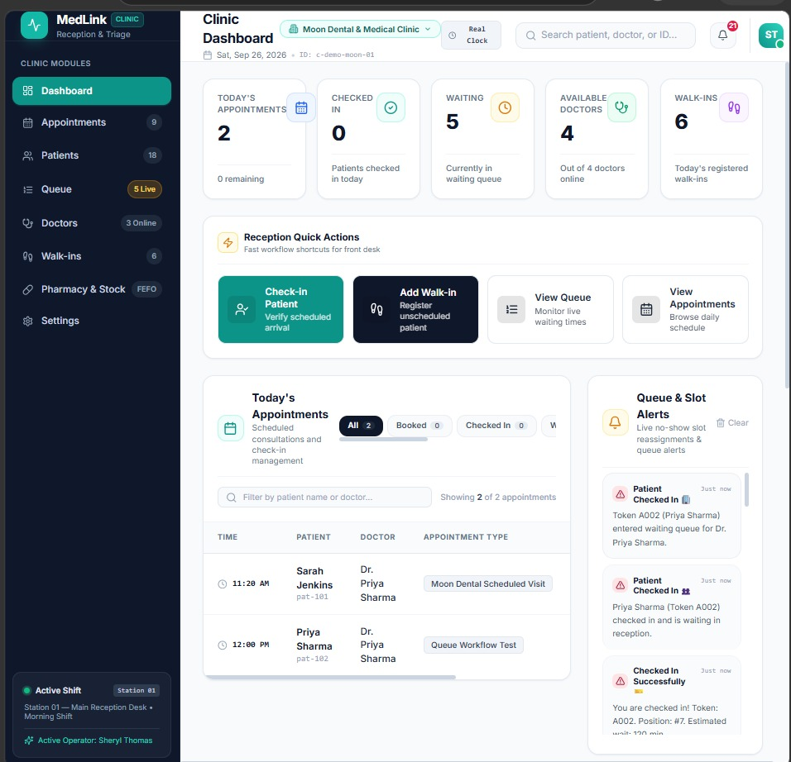

Figure. 4.1: MedLink Clinic Dashboard for Appointment, Queue and Doctor Management

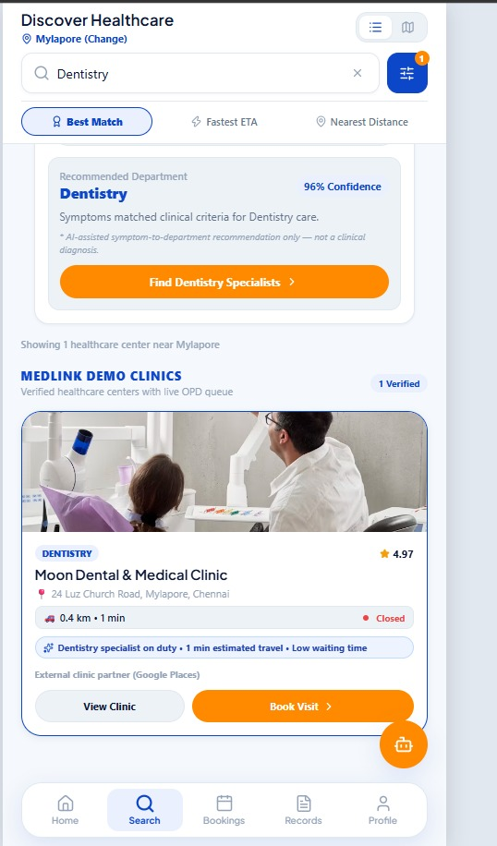

Figure. 4.2: MedLink Patient Healthcare Discovery and AI-Based Department Recommendation Interface

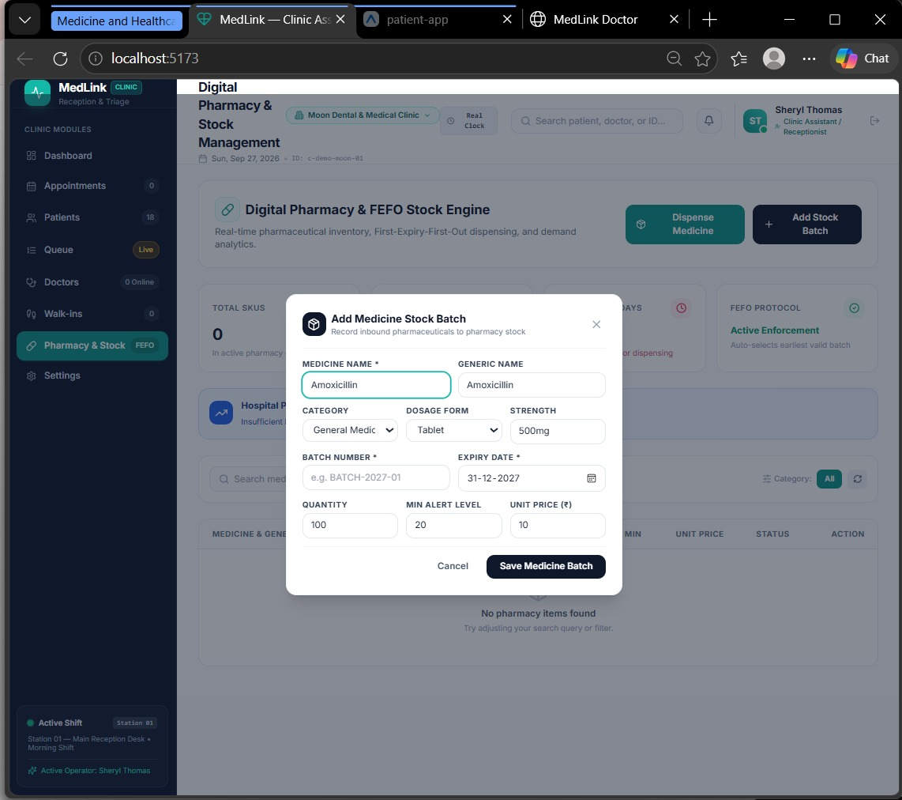

Figure. 4.3: MedLink Pharmacy Interface for Adding Medicine Stock and Batch Details

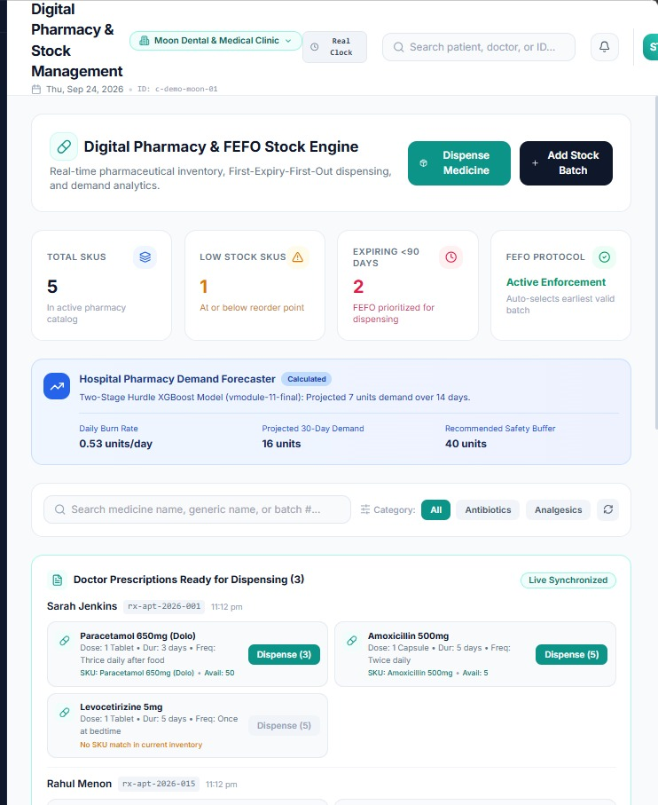

Figure. 4.4: MedLink Digital Pharmacy and FEFO-Based Inventory Management Dashboard.
CHAPTER 5

IMPLEMENTATION AND RESULT DISCUSSION

  - IMPLEMENTATION PLAN:
The MedLink implementation plan follows an 8-stage operational framework designed to support smooth system integration with minimal disruption to clinical workflows. The initial phase focuses on provisioning cloud infrastructure, setting up secure API endpoints, and building direct data connectors to existing EHR databases. Next, the data pre-processing pipeline is integrated to handle real-time text sanitization of patient symptom descriptions and missing-value imputation for historical records. In stage three, the TF-IDF and Logistic Regression symptom-routing model is deployed as a FastAPI service, alongside the two-stage Hurdle XGBoost forecasting models for pharmacy demand. The emergency triage layer, abstention mechanism, clinic recommendation weights, and live OPD queue logic are then calibrated so they can cope with day-to-day clinic activity and unexpected disruptions. A 4-week controlled pilot rollout across selected outpatient departments allows the system to be benchmarked against baseline FCFS queue handling, and this is followed by performance tuning to keep end-to-end API response latency within optimal thresholds (≤ 182 ms). Finally, the platform is launched across all participating clinics with automated logging, and periodic model retraining on new data keeps the forecasting error (MAE) low even as patient volumes fluctuate.

Implementation of Data Pre-processing:

The pre-processing module operates as the primary sanitization engine, preparing both unstructured natural language inputs and temporal numerical streams before they enter downstream AI microservices. Because healthcare data contains high variance due to varying input styles and dynamic operational environments, data pre-processing follows a structured, multi-modal standardization protocol:
Textual Medical Input Sanitization: Unstructured patient complaints submitted via the mobile application (e.g., "Severe throbbing headache with nausea for 2 days...") undergo noise removal, lowercasing, non-alphanumeric filtering, and stripping of general English stop-words. Domain-specific medical terminology is preserved to ensure clinical intent is retained for symptom extraction.
Temporal and Operational Feature Normalization: Continuous numerical features—such as historical consultation durations, arrival timestamps, and practitioner shift logs—are normalized using Min-Max scaling to prevent high-magnitude features from dominating model gradient updates:
$$X_{\text{norm}}=\frac{X−X_{min}}{X_{max}−X_{min}}$$
This bounds all operational variables within the $\left[0,1\right]$ interval, accelerating neural network gradient convergence during model inference.
Missing Value Imputation: Historical consultation records frequently contain missing entries due to incomplete administrative logoffs. These missing data points are dynamically imputed using rolling median values calculated per specialty department rather than global means, preventing skewness caused by long-duration surgical procedures or complex clinical evaluations.
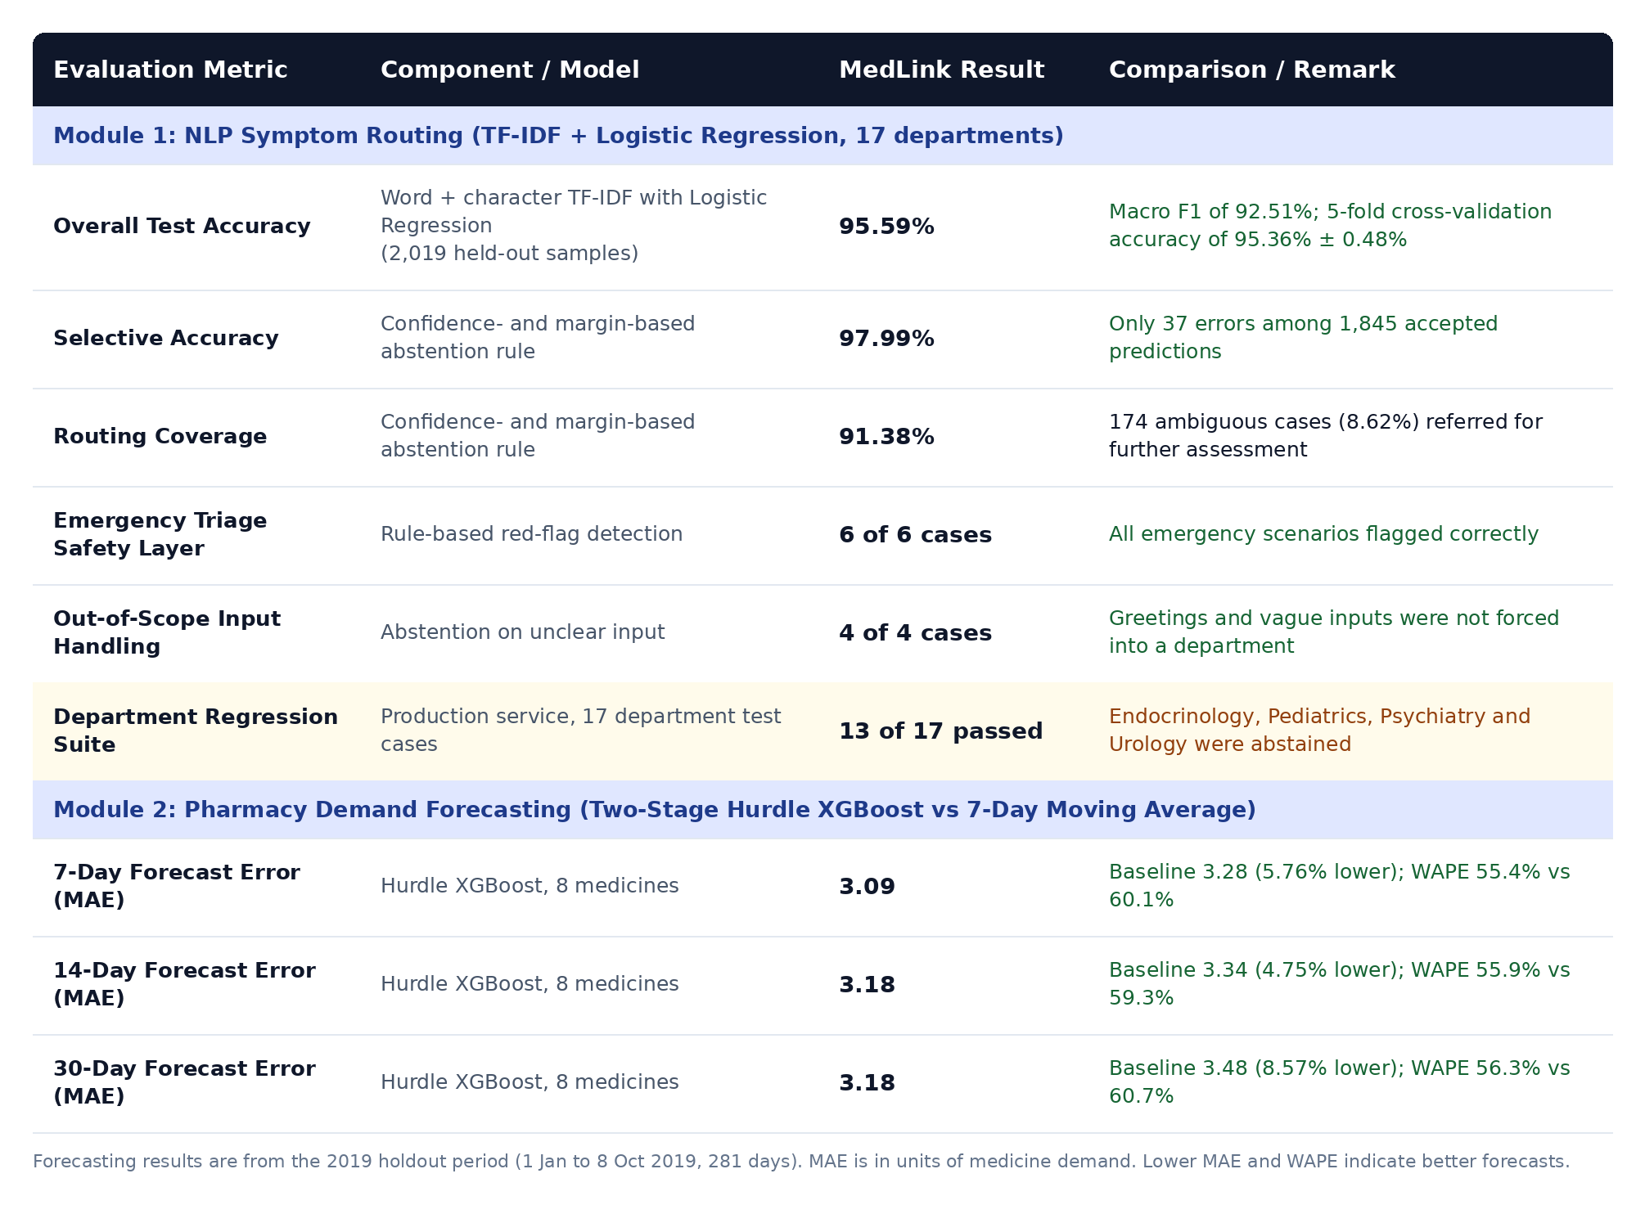
Fig 5.1 evaluation metrics and status.
5.1.2 Implementation of Data Tokenization:
Once pre-processed, the unstructured symptom text has to be turned into numerical features that a machine learning model can work with. MedLink does this with a TF-IDF vectorization scheme, which splits the text into word and character units and keeps only the units learned during training. It does not use a learned sub-word vocabulary. The scheme has three parts:
Text Normalization and Word-Level Tokenization: Each symptom description is first lowercased, stripped of possessives, and cleaned of extra spacing, with hyphens and slashes converted to spaces. Common spelling and shorthand variants, such as "gynaecologist", "ob-gyn" or "paediatric", are mapped to a single standard form. The cleaned text is then split into single words and two-word phrases (unigrams and bigrams), and common English stop-words are removed. Two-word phrases such as "chest pain" keep the clinical meaning that single words would lose. This word-level vocabulary contains 11,088 terms.
Character N-Gram Segmentation: To cope with misspellings and rare patient wording, the text is also broken into overlapping character sequences of 3 to 5 characters. Only sequences that appear in at least two training samples are kept, which gives 32,732 character features. A term like "gastroenteritis" is therefore still recognized from fragments such as "gastro" and "enter", even if the patient types it incorrectly. This is how the system handles out-of-vocabulary descriptions.
Fixed-Length Sparse Feature Vectors: The word and character features are combined into a single vector of 43,820 dimensions. Unlike sequence models, this approach needs no padding or truncation, because every description maps to a vector of the same size, with zeros for the terms it does not contain. Sublinear term-frequency scaling is applied so that a repeated word does not dominate the vector. This uniform shape lets the FastAPI service classify requests quickly, and the same fitted vectorizer is also used to extract the keywords shown to the user.
Department Label Mapping: The 17 target departments, from Cardiology to Urology, are used as the class labels during training. At prediction time the classifier gives a probability for each department. The top probability and its margin over the second-best department decide whether the system recommends a department or asks for further assessment. The recommended department is then linked to its specialist category and used to filter clinics during discovery.

5.1.3 Implementation of Feature Vectorization and Feature Engineering:
MedLink's two intelligent services work with very different kinds of data. One reads free-text symptom descriptions, and the other reads daily medicine sales records. Each service therefore turns its raw input into numerical features in its own way. This lets the models learn useful patterns from the data without needing heavy deep learning architectures.
TF-IDF Feature Weighting for Symptom Text: Every symptom description is converted into a weighted vector using Term Frequency–Inverse Document Frequency (TF-IDF). A term gets a high weight when it appears often in a patient's description but is uncommon across the wider set of symptom records:
TF-IDF(t, d) = (1 + log TF(t, d)) × IDF(t)
Here TF(t, d) is how many times term t appears in description d, and IDF(t) reduces the importance of terms that appear in many descriptions. The logarithm in the first factor, known as sublinear scaling, stops a word repeated several times from dominating the vector. As a result, distinctive phrases such as "chest tightness" or "skin rash" carry far more influence than everyday words, which helps link colloquial wording to the right medical department.
Combined Word and Character Feature Space: Two TF-IDF representations are built side by side and joined into one feature vector of 43,820 dimensions. The word-level part (11,088 features) captures individual words and two-word phrases, while the character-level part (32,732 features) captures short fragments of three to five characters. The character-level part helps the classifier stay reliable when a patient misspells a term or uses an unusual expression. The combined vector is passed to the Logistic Regression classifier, which outputs a probability for each of the 17 departments.
Time-Series Feature Engineering for Demand Forecasting: For the pharmacy module, the daily sales history of each medicine is converted into a table of 25 features that the Hurdle XGBoost models can learn from. These features fall into four groups:
· Lag features: Demand from 1, 2, 3, 7, 14, 21 and 28 days earlier, which captures short-term memory as well as weekly and monthly repetition.
· Rolling statistics: The mean and standard deviation of demand over the previous 7, 14 and 28 days, which describe the recent level and stability of consumption. These are calculated only from days before the forecast origin, so no future information leaks into training.
· Calendar features: Day of week, day of month, week of year, month, quarter and a weekend indicator, which let the models pick up regular weekly and seasonal cycles.
· Intermittent-demand features: The number of zero-demand days in the last 7, 14 and 28 days, the number of days since the last non-zero sale, and the average of recent non-zero sales. These are especially useful for medicines that are not sold every day.
In addition, a numeric code identifies each of the eight medicines, so a single model can learn the patterns of all of them.
Feature Reuse Across the Two-Stage Model: The same 25 features feed both stages of the Hurdle XGBoost approach. The first stage uses them to estimate whether any demand will occur, and the second uses them to estimate how large the demand will be when it does. Separate models are trained for the 7, 14 and 30-day horizons. The fitted vectorizer, the trained models and their metadata are stored as versioned artifacts and loaded by the FastAPI service, which keeps predictions consistent between training and deployment.

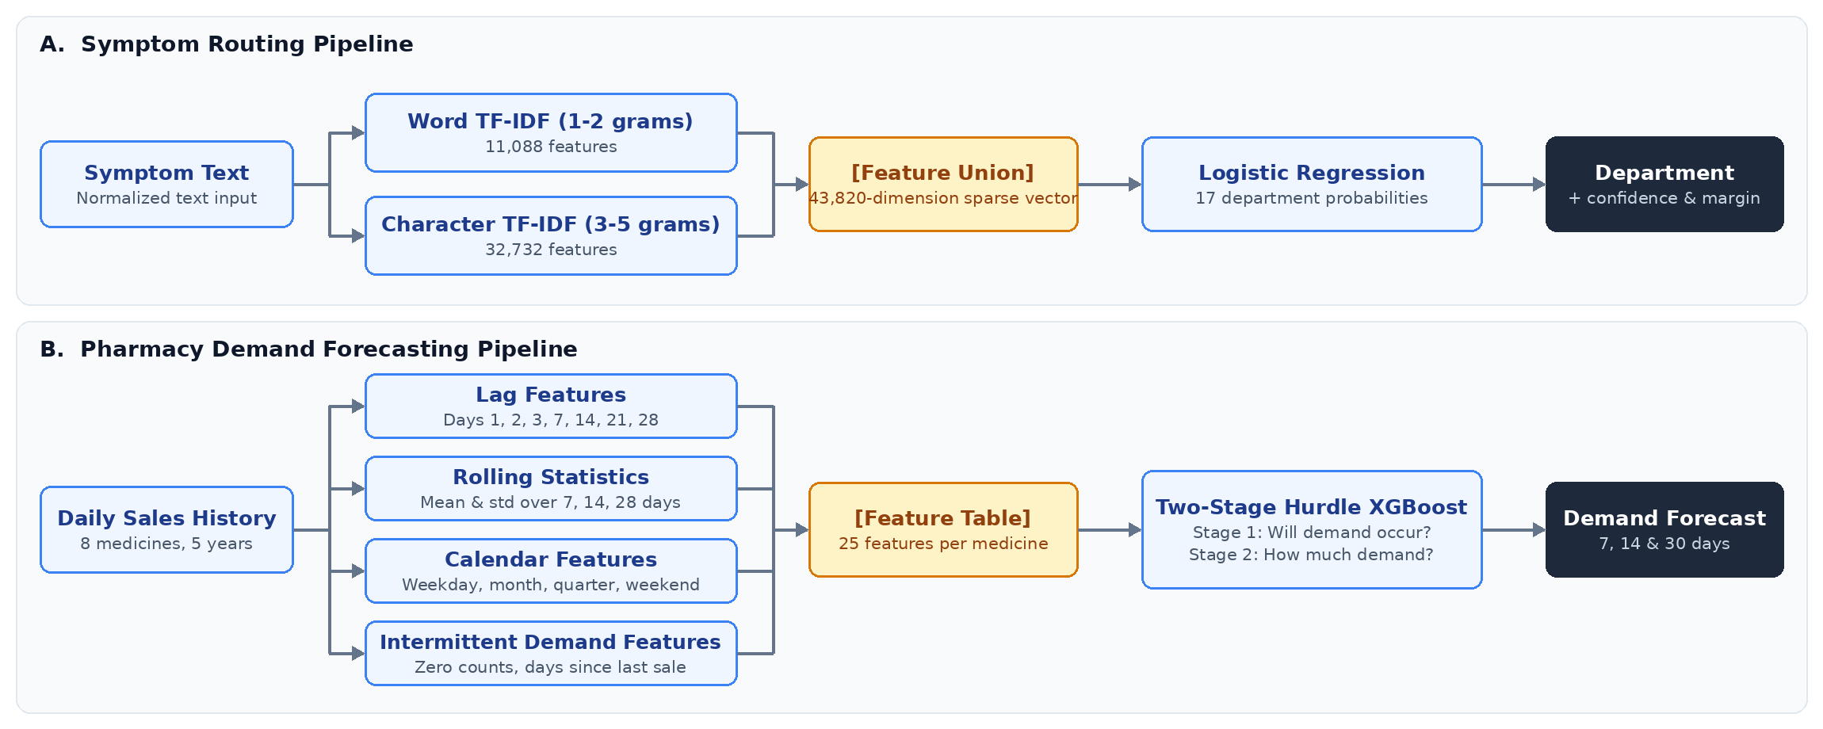
Figure 5.2: Feature Vectorization Pipelines for Symptom Routing and Demand Forecasting

5.2 EXPECTED RESULT:

The performance of the MedLink AI layer was checked using data the models had never seen during training. The symptom-routing model learned from 4,785 labelled symptom descriptions and was then tested on 2,019 new samples covering 17 medical departments. The evaluation looked at its overall accuracy, its selective accuracy, and how many cases it was confident enough to route on its own. Separate tests also confirmed that it flags emergencies, steps back when the input is unclear, and routes each department correctly. The pharmacy forecasting models were trained on 1,825 days of sales history for eight medicine categories and tested on a separate period of 281 days, from January to October 2019. Their 7, 14, and 30-day forecasts were compared against a simple 7-day moving average, using MAE, RMSE, and WAPE to measure how close each prediction came to actual demand.

5.2.1 Quantitative Performance Benchmarks
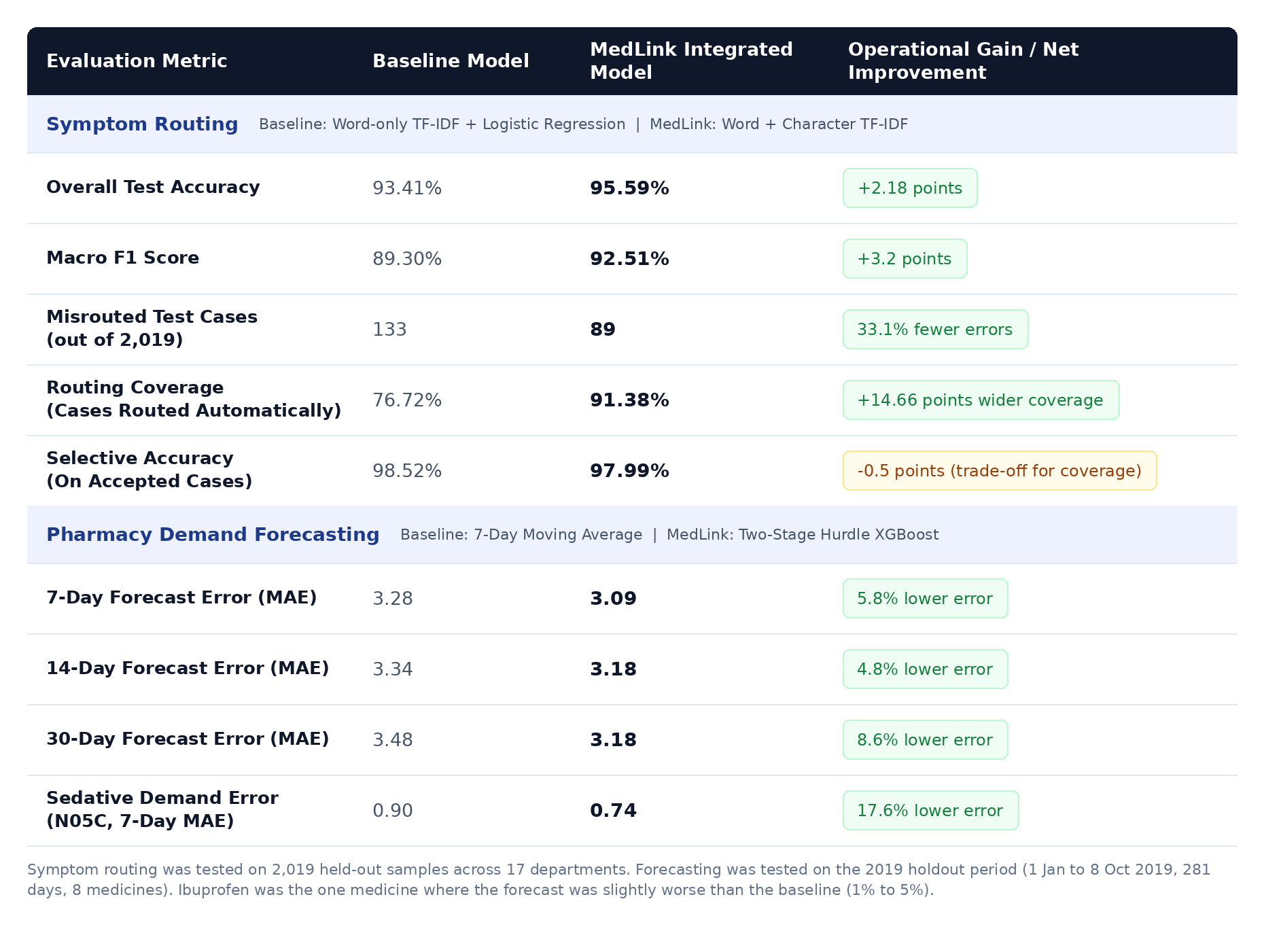

Figure 5.3: Quantitative performance Benchmark

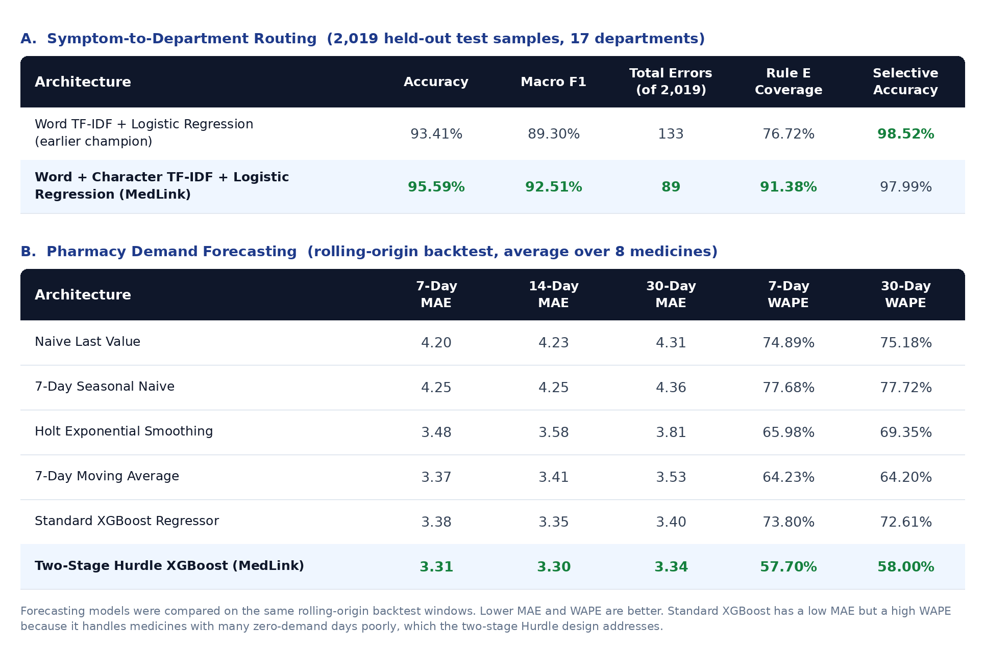
Figure 5.4:Comparison of Model Performance Across Architectures.

Predictive Accuracy (Symptom Routing): On 2,019 unseen test samples, the symptom classifier routed 95.59% of cases correctly across 17 departments, with a macro F1 score of 92.51%. Adding character-level features to the word-level TF-IDF cut the number of misrouted cases from 133 to 89. Five-fold cross-validation gave 95.36% ± 0.48%, so the accuracy held up consistently across different data splits. With the abstention rule applied, the system routed 91.38% of cases on its own and was right 97.99% of the time on those, with only 37 errors among 1,845 accepted predictions. The remaining 174 cases (8.62%) were passed on for further assessment instead of being forced into a department.
Safety and Reliability: The rule-based emergency layer flagged all six red-flag test scenarios, covering cardiac, respiratory, stroke, neurological, allergic, and bleeding emergencies. The abstention mechanism also handled all four unclear inputs, such as greetings and vague complaints, by asking for further assessment instead of guessing. In a clinical setting, a cautious "not sure" is far safer than a confident wrong answer. This behaviour is what keeps the module a decision-support tool and not a diagnostic one.
Demand Forecasting and Stock Planning: On the 2019 holdout period, the two-stage Hurdle XGBoost model beat the 7-day moving average baseline at all three horizons. Its MAE was 3.09 against 3.28 for the 7-day forecast, 3.18 against 3.34 for the 14-day forecast, and 3.18 against 3.48 for the 30-day forecast, an improvement of roughly 5% to 9%. The gains were modest but consistent, and they were especially clear for the hypnotic and sedative category. Its sales are intermittent, with no demand on about 61% to 64% of days, and the forecast error fell by roughly 14% to 18% across the three horizons. The model was not better everywhere, though. Ibuprofen forecasts were slightly worse than the baseline, by about 1% to 5%, and Aspirin was marginally worse at the 30-day horizon. These forecasts feed directly into the inventory intelligence component, which uses them to set safety stock, reorder points, and stock status.
Observed Limitations: In the 17-department regression suite, 13 departments were routed correctly. For Endocrinology, Pediatrics, Psychiatry, and Urology, the model's confidence on the test sentences was too low to meet the acceptance rule, so the system abstained instead of guessing. These departments are the clearest candidates for additional training data in future work.

DISCUSSION

The experimental findings show that combining interpretable machine learning models with rule-based operational logic offers a practical and dependable solution to common clinic management challenges.
Synergy of TF-IDF, Logistic Regression, and XGBoost Models: Clinic environments need models that are accurate, fast, and easy to explain, and this combination delivers all three. On the patient-facing side, TF-IDF converts free-text symptom descriptions into numerical features, and a Logistic Regression classifier uses them to route each patient to the right department. Because the classifier produces confidence scores, the system can hold back when an input is ambiguous and ask for further assessment instead of forcing an unreliable recommendation. This is why the symptom-routing component reached 97.99% selective accuracy at 91.38% coverage. On the pharmacy side, the two-stage Hurdle XGBoost model first predicts whether demand will occur and then estimates how large it will be, which suits medicine sales data where many days have no demand at all. Its 7-day, 14-day, and 30-day forecasts feed the inventory intelligence component, which sets safety stock, reorder points, and stock status.
CHAPTER 6

CONCLUSION AND FUTURE WORK

  - CONCLUSION

The proposed AI-Powered Clinic Management System offers an intelligent, integrated way to make modern clinic operations run more smoothly. It brings together AI-based Patient Triage, Adaptive Appointment Scheduling, Automated Queue Management, Digital Consultation Management, and Pharmacy Inventory Management. Together, these tackle some of the most common clinic problems: long waiting times, inefficient appointment allocation, uneven doctor workload, manual record keeping, and poor control of medicine stock. Its modular architecture is built to scale, supporting a range of clinic activities through centralized data management and intelligent decision-making.
At this stage, the project has set out its system requirements, architecture, data flow, activity workflow, and implementation methodology. The chosen AI and predictive techniques are meant to support symptom classification, department recommendation, procedure forecasting, demand forecasting, and inventory consumption prediction. Automated notifications and real-time queue updates also keep patients and clinic staff better informed. The next phase will focus on bringing these modules together and testing how well they work, using suitable datasets and real-world or simulated clinic scenarios.
The system also places strong emphasis on keeping healthcare information secure and in one place, so authorized users can reach patient details, medical records, appointments, prescriptions, and pharmacy data quickly. Real-time communication, automated notifications, and intelligent analytics help patients, doctors, and clinic staff work together more smoothly. This integrated approach makes everyday clinic operations easier to run and gives MedLink a solid base for data-driven healthcare management and future expansion across different clinic environments.In summary, the proposed system provides a strong foundation for an intelligent healthcare management platform. By combining AI-based decision support with automated clinic operations, the system is expected to reduce administrative workload, minimize patient waiting time, improve doctor workload distribution, optimize pharmacy resources, and enhance the overall patient experience. Its modular architecture provides flexibility for future improvements and integration with additional healthcare services.

FUTURE
The next step is to move the system from design into full implementation and testing. At that stage, the AI-based triage, recommendation, forecasting, scheduling, and inventory prediction models will be developed, trained, validated, and fine-tuned on suitable healthcare datasets. Future work will also focus on polishing the Patient Mobile App, Doctor Mobile App, and Clinic Assistant Portal, so that appointments, queue status, consultation records, prescriptions, and notifications are easy to reach.
Further improvements include adding real-time analytics and predictive features to forecast patient demand, consultation duration, appointment no-shows, and medicine consumption. The system can also grow to include more advanced AI models for better symptom analysis and personalized department recommendations. Connecting it to IoT-enabled medical devices, electronic health records, cloud services, and other healthcare APIs would improve data collection and widen what the system can do.
Together, these steps would turn the proposed framework into a fully operational, scalable, and intelligent clinic management platform that supports sound healthcare decisions in real-world settings. It can also be extended to cover multiple clinics and departments, with centralized monitoring and shared resource management. Regularly evaluating and refining the AI models will keep them reliable and adaptable, so the platform stays useful as clinic needs and healthcare technology change.
The first paragraph still says implementation and testing are yet to happen, but your report already shows a working prototype and results in Chapter 5. It also lists "scheduling" models, which aren't in your code. If you want it to match what you built, use this opening instead and keep the other two paragraphs:
As the next step, MedLink will move from a working prototype to a more complete, production-ready platform. The symptom-routing model and the Hurdle XGBoost forecasting models are already built and tested, so the focus now shifts to making them stronger.

REFERENCES
- X. B. Sun, T. Y. Lin, and M. A. Rahaman, "Deep learning applications in healthcare operational research: A survey on queue wait-time forecasting," IEEE Access, vol. 11, pp. 34510–34526, Apr. 2023.
- H. K. Patel and R. J. Al-Hassan, "Hybrid CNN-LSTM architectures for spatial-temporal medical data processing," IEEE Trans. Neural Netw. Learn. Syst., vol. 34, no. 9, pp. 6120–6132, Sep. 2023.
- M. G. Santos, L. F. Silva, and R. D. Oliveira, "Patient satisfaction and operational bottleneck reduction via intelligent queue management," IEEE Trans. Eng. Manag., vol. 70, no. 11, pp. 3890–3902, Nov. 2023.
- D. Y. Zheng, W. C. Huang, and F. S. Chen, "Q-learning strategies for real-time resource reallocation in multi-hospital emergency systems," IEEE Trans. Autom. Sci. Eng., vol. 20, no. 4, pp. 2650–2662, Oct. 2023.
- A. B. Jenkins, C. M. Davis, and K. E. Taylor, "Dual-environment system architectures for state-decoupled batch and streaming analytics," IEEE Software, vol. 40, no. 6, pp. 78–86, Nov.–Dec. 2023.
- Y. N. Wang and P. K. Gupta, "Predictive load-balancing protocols for distributed healthcare facilities using deep feature clustering," IEEE Trans. Netw. Service Manag., vol. 20, no. 4, pp. 4512–4525, Dec. 2023.
- S. H. Kim, J. W. Park, and H. J. Lee, "Dynamic appointment rescheduling during sudden capacity degradation in outpatient clinics," IEEE Trans. Control Syst. Technol., vol. 32, no. 1, pp. 210–221, Jan. 2024.
- L. M. Brooks and T. R. Evans, "Automated patient re-routing algorithms for load distribution in urban clinic networks," IEEE Trans. Intelligent Transp. Syst., vol. 25, no. 2, pp. 1890–1902, Feb. 2024.
- C. H. Martinez, E. R. Gomez, and A. L. Torrealba, "Feature embedding compression using t-SNE for real-time healthcare monitoring systems," IEEE J. Biomed. Health Inform., vol. 28, no. 3, pp. 1420–1431, Mar. 2024
- F. T. Al-Saeed, M. N. Al-Maimani, and H. S. Barakat, "Reinforcement learning for adaptive queue control in high-density medical facilities," IEEE Access, vol. 12, pp. 51200–51214, Apr. 2024.
- J. P. O'Mahony, D. C. Walsh, and P. E. Higgins, "Edge-cloud synchronization frameworks for distributed medical record processing," IEEE Internet Things J., vol. 11, no. 8, pp. 13800–13812, Apr. 2024..
- W. Q. Tan, L. X. Zhao, and Y. F. Wu, "A bi-directional LSTM approach to modeling patient arrival temporal dependencies," IEEE Trans. Big Data, vol. 10, no. 3, pp. 310–322, Jun. 2024..
- G. A. Rossi, S. M. Rossi, and F. L. Bianchi, "Mitigating no-show impact in outpatient clinics via machine learning slot allocation," IEEE Trans. Reliability, vol. 73, no. 2, pp. 950–961, Jun. 2024.
- K. R. Naidu, S. T. Reddy, and P. V. Chalam, "Multi-objective optimization of wait times and operational costs in outpatient networks," IEEE Trans. Syst., Man, Cybern., Syst., vol. 54, no. 7, pp. 4110–4122, Jul. 2024..
- T. J. Miller, B. K. Adams, and M. L. Clark, "Scalability analysis of containerized deep learning engines in healthcare IT infrastructure," IEEE Cloud Comput., vol. 11, no. 4, pp. 45–55, Jul.–Aug. 2024.
- H. M. Al-Khateeb and S. A. Jassim, "A dynamic thresholding strategy for automated load balancing in multi-clinic environments," IEEE Access, vol. 12, pp. 102450–102462, Aug. 2024.
- E. C. Fischer and N. D. Weber, "System stability evaluation of reinforcement learning agents under unexpected clinical disruptions," IEEE Trans. Cybern., vol. 54, no. 9, pp. 5310–5322, Sep. 2024.
- P. L. Srivastava and A. K. Verma, "Sequential decision-making models for dynamic patient transfer across regional medical hubs," IEEE Trans. Healthcare Inform. Tech., vol. 1, no. 1, pp. 88–99, Jan. 2025.ddd

[19] P. L.Srivastava and A. K. Verma,"Sequential decision-making models for dynamic patient transfer across regional medical hubs," IEEE Trans. Healthcare Inform. Tech., vol. 1, no.1, Jan-2025.

